

3-Software Requirement Specification
– Da Nang, May 2026 –
1
TABLE OF CONTENTS

Pro-Sport Complex Management System — Software Requirement Specification (SRS)

1. Product Overview ..................................................................................................................5
1.1 Context Diagram ......................................................................................................5
1.2 Main Workflows .......................................................................................................7
1.2.1 Court Booking & Double-Booking Prevention ..........................................7
1.2.2 Escrow Matchmaking & Financial Custody ...............................................8
2. User Requirements .................................................................................................................9
2.2 Use Cases ...................................................................................................................10
2.2.1 Diagram(s) ..................................................................................................10
2.2.2 Descriptions .................................................................................................16
3. Functional Requirements .........................................................................................................20
3.1 System Functional Overview .........................................................................................20
3.1.1 Screens Flow.....................................................................................................20
3.1.2 Screen Descriptions.........................................................................................23
3.1.3 Screen Authorization...........................................................................................24
3.1.4 Non-Screen Functions........................................................................................26
3.1.5 Entity Relationship Diagram..............................................................................26
3.2 Register ..........................................................................................................................28
3.3 Login ..............................................................................................................................31
3.4 Forgot Password Function Description ..........................................................................33
3.5 Matchmaking Management ...........................................................................................36
3.5.1 Create Match Post ................................................................................................36
3.5.2 Edit Match Post ...................................................................................................38
3.5.3 Cancel Match Post ...............................................................................................39
3.6 Court Search & Filter .....................................................................................................41
3.7 View Real-Time Availability Grid ................................................................................42
3.8 View Court Details & Facilities .....................................................................................43
3.9 User Profile Management ..............................................................................................44
3.10 Submit E-KYC Verification ........................................................................................45
3.11 Court Booking Management ........................................................................................46
3.12 Cancel Court Booking .................................................................................................48
3.13 Join Match & Escrow Deposit .....................................................................................49
3.14 Manage Match Members (Approve/Reject) ................................................................50
3.15 Withdraw from Match Session ....................................................................................51
3.16 Booking History & Invoices .......................................................................................52
3.17 My Matches Management ...........................................................................................53
3.18 VNPay Payment Integration ........................................................................................54
3.19 Webhook IPN Processing ............................................................................................55
3.20 AI Chatbot Assistant ....................................................................................................56
3.21 AI-Based Court Recommendation ...............................................................................57
3.22 Rate & Review Players (Trust Score) .........................................................................58
3.23 Fraud Handling & No-Show Reporting ......................................................................59
3.24 QR Code Check-in (Staff) ...........................................................................................60
3.25 Check-out & End Session (Staff) ................................................................................61
3.26 POS & Equipment Rental Management ......................................................................62
3.27 Asset Damage Inspection & Surcharge .......................................................................63
3.28 Issue Promotional Voucher (Try-Before-You-Buy) ...................................................64
3.29 User Management & Access Control ...........................................................................65
3.30 Approve E-KYC Profiles .............................................................................................66
3.31 Court & Pricing Configuration (Admin) .....................................................................67
3.32 Equipment Catalog & Inventory Management ............................................................68
3.33 Escrow Refund & Dispute Handling ...........................................................................69
3.34 Admin Dashboard & Statistics ....................................................................................70
3.35 Send System Notifications (Email/In-app) .................................................................71
4. Non-Functional Requirements..................................................................................72
4.1 External Interfaces .........................................................................................................72
4.1.1 User Interfaces .....................................................................................................72
4.1.2 Software Interfaces.........................................................................................72

4.2 Quality Attributes .......................................................................................................72
5. Requirement Appendix ........................................................................................................74
5.1 Business Rules ...............................................................................................................74
5.2 Application Messages List .............................................................................................75
3
I. Record of Changes
Date | A*  M,  D | In charge | Change Description

*A - Added M - Modified D – Deleted

1. Introduction
1.1 Document Purpose
This Software Requirements Specification (SRS) document is created to define in detail and comprehensively the functional, non-functional requirements, and business constraints of the Pro-Sport Complex system (An AI-integrated smart sports complex management and player connection system). The document serves as a standard reference baseline to unify the common language among stakeholders, including: Developers, Testers, Project Managers (PM), and Customers/Investors, ensuring the delivered system accurately and adequately meets the established business objectives.
1.2 Project Overview
In the context of a booming sports training movement (especially adversarial sports like Badminton, Pickleball, and Tennis), the demand for finding courts and connecting with the player community has skyrocketed. However, the market lacks a comprehensive technological solution. Court operation processes are still predominantly manual, players face difficulties in finding suitable teammates, and most critically, the issue of "no-shows" (bùng kèo) causes frustration and financial losses for both organizers and court owners.
Pro-Sport Complex was established as a multi-agent intermediary platform, aiming to comprehensively digitize the sports complex operation process. The system not only provides real-time court availability management but also integrates an Escrow wallet for financial transparency and anti-"no-show" mechanisms. This is combined with an AI Chatbot that analyzes natural language to optimize matchmaking and provide deeply personalized court recommendations for each user.
2. Scope
2.1 Business Scope
The system focuses on solving the following core business flows:
- Court & Availability Management: Digitize the real-time matrix, allowing online booking and automated court status updates.
- Matchmaking & Match Organization: Support users in creating, managing, and joining exchange "matches" with a reputation rating mechanism.
- Escrow Payment Processing: Utilize an intermediary wallet to hold the deposits of match participants, automatically refunding or penalizing based on actual "check-in" results.
- On-site Operations: Provide tools for staff to handle QR code check-ins, manage equipment rental/return, calculate damage surcharges, and sell value-added services (F&B).
- Smart Support (AI Chatbot): Integrate AI to provide consultation, assist in checking availability, and find matches using natural language.
2.2 User Scope
The system serves 4 main Actors:
- Guest: Can access and look up court information and view public matches but does not have deep interaction rights.
- Customer (Player): Authenticated (E-KYC) users who have full rights to book courts, create/join matches, make payments, and use services.
- Staff (Coordinator): Operate directly at the court, handle check-in/out procedures, conduct inventory checks, and log incidents.
- Admin (Court Owner): Manage the system globally, configure Dynamic Pricing, handle disputes and complaints, and monitor statistical reports.
2.3 Out of Scope
- The system does not manage IoT hardware devices at the court (such as automatic lighting toggles, magnetic doors, or AI match-monitoring cameras).
- Does not provide Logistics services for sports equipment outside the sports complex premises.
- Does not act as a multi-functional social networking platform (no newsfeed, stories, etc.), strictly focusing on sports connections.
3. Analysis of Current Systems (As-Is Systems & Current Context)
Before proposing the Pro-Sport Complex solution, an assessment of current systems and operating methods (As-Is) in the market reveals distinct pain points:
3.1 Traditional Court Booking Platforms (e.g., SanCaulong.vn, sports directories)
- Current Status: Primarily operate as digitized "Yellow Pages". They provide basic information regarding the location, phone number, and reference prices of court clusters.
- Limitations:
  - Static Data: Lacks real-time availability synchronization. Players still have to manually call the court owner to confirm open slots.
  - Single Functionality: No community connection features, completely ignoring the "matchmaking" and exchange organization segment.
  - Poor Administration: Court owners lack a backend to manage revenue or cancellation policies.
3.2 Social Media Groups (Facebook Groups, Zalo, Telegram)
- Current Status: Currently the primary channel for players to post "finding teammates", "sharing court fees", or for clubs to recruit members.
- Limitations:
  - Financial Risks & "No-shows": Due to the lack of upfront payment obligations, the situation where players register but do not show up occurs frequently. Organizers (Hosts) often have to compensate for the court fees out-of-pocket.
  - Difficulties in Financial Management: Collecting fragmented cash or manual bank transfers from multiple individuals is highly time-consuming and prone to errors.
  - Lack of Identity (E-KYC) and Reputation: It is very difficult to verify the actual skill level of players, and there is no rating system to filter out individuals with a history of poor behavior.
3.3 Internal Management Processes of Current Court Owners
- Current Status: The majority of small to medium-sized sports courts are managed via paper ledgers, whiteboards, or Excel files/internal Zalo groups.
- Limitations:
  - Resource Waste: It is very difficult to optimize the fill-rate for fragmented idle time slots ("dead hours").
  - Revenue Leakage: Loose management processes for equipment inventory (rental rackets, balls, shoes) and sales (beverages) easily lead to inventory discrepancies.
  - Lack of Flexibility: No Data Analytics tools are available to automatically configure Dynamic Pricing based on supply and demand.

I. Overview

1. User Requirements

1.1 Actors

Actor Description
Actor | Role & Key Responsibilities
Guest | Unregistered user. Can view courts, schedules, pricing, and open matches.
Customer | Registered user. Can book courts/equipment, pay, manage matches (host/join), and use the Escrow Wallet.
Staff | Facility employee. Handles check-ins, manages physical equipment, verifies e-KYC, and reports issues.
Admin | Top-level manager. Has full system control, manages users/pricing, resolves disputes, and views reports.
System | Background process. Automates unpaid booking cancellations, equipment liquidation, and escrow fund transfers.

1.2 Use Cases

a. Diagram(s)

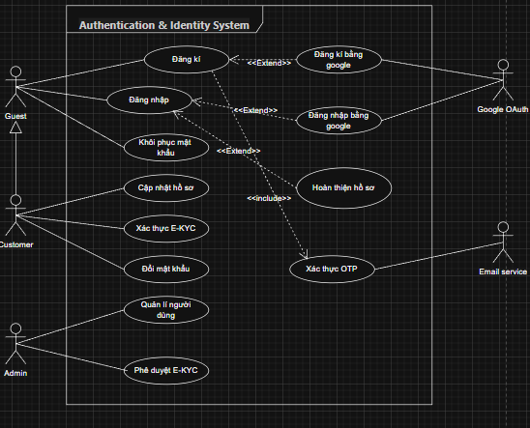
Figure 1. Authentication use case diagram
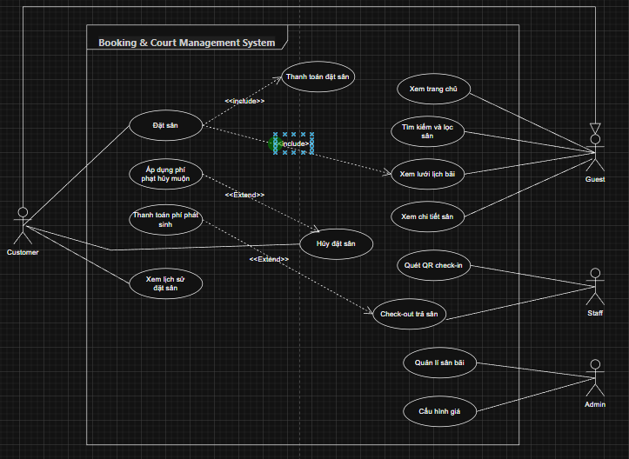
Figure 2. Booking & Court Management System use case diagram

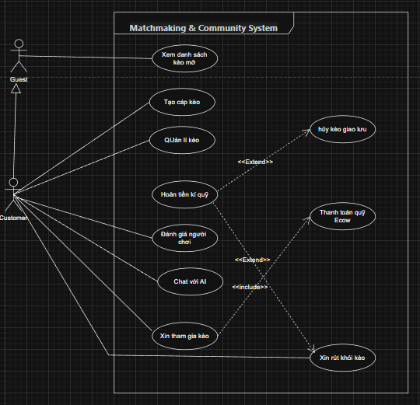
Figure 3. Matchmaking & Community System use case diagram

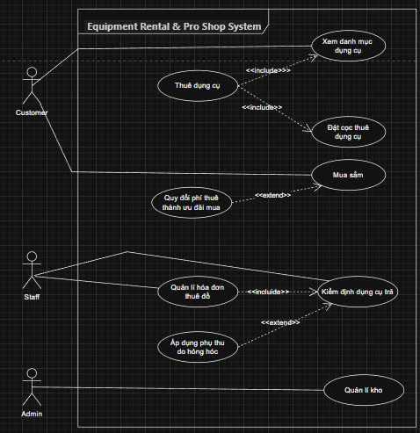
Figure 4. Equipment Rental & Pro Shop System use case diagram

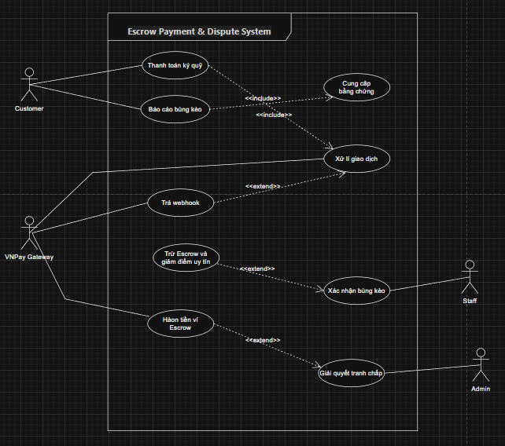
Figure 5. Escrow Payment & Dispute System use case diagram

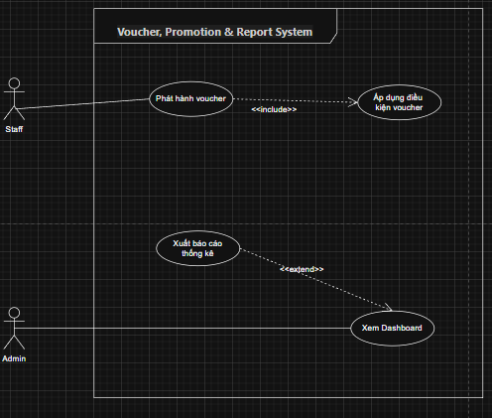
Figure 6. Voucher, Promotion & Report System use case diagram

b. Descriptions

ID | Feature | Use Case | Description
UC-01 | Authentication | Account Registration | Guests register a new account using an email or phone number to access Pro-Sport Complex features. The system sends an OTP for verification before activating the account.
UC-02 | Authentication | Login | Users with an existing account log in using their email/phone number and password. The system authenticates the credentials and redirects to the respective homepage based on their role (Customer, Staff, Admin).
UC-03 | Authentication | Logout | Logged-in users can log out of the system. The session is terminated, and the user is redirected to the Guest homepage.
UC-04 | Authentication | Login | with GoogleUsers can quickly log in via their Google account. The system redirects to the Google OAuth page and automatically creates an account if it is their first time logging in.
UC-05 | Authentication | Password Recovery | Users who forget their password can request an OTP sent to their registered email. Upon successful OTP verification, the user can set a new password.
UC-06 | Authentication | Change Password | Logged-in users can change their password by entering the old password for verification, then entering the new one. The system checks password strength before updating.
UC-07 | Authentication | Role-Based Access Control | The system grants access based on 4 roles: Guest (public view), Customer (book courts, join matches), Staff (on-site operations), and Admin (global management). Each role can only access its corresponding features.
UC-08 | User Profile & E-KYC | View Personal Profile | Customers view their personal profile information, including full name, email, phone number, avatar, E-KYC status, reputation score, and platform activity history.
UC-09 | User Profile & E-KYC | Update Profile | Customers edit personal information such as full name, date of birth, gender, and avatar. Certain fields (email, phone number) require OTP verification when changed.
UC-10 | User Profile & E-KYC | E-KYC Verification | Customers verify their identity by uploading two-sided ID card photos and a portrait photo. The system sends the profile to the Admin for approval. E-KYC status is updated upon Admin confirmation. Only E-KYC verified Customers can create/join matchmaking matches.
UC-11 | Court Discovery & Browsing | View Homepage | Guests/Customers view the system homepage featuring sports complex introductions, highlighted events, popular courts, and open matchmaking matches.
UC-12 | Court Discovery & Browsing | View Court Schedule Grid | Guests/Customers view a real-time court schedule matrix (Court Grid) showing the status of all courts by time slots: Available (green), Booked (red), In Use (yellow). The grid updates automatically in real-time.
UC-13 | Court Discovery & Browsing | Search and Filter Courts | Guests/Customers search for courts using multiple criteria: court name, sport type (Badminton/Pickleball), time slot, price range, and amenities. Results are displayed as a paginated list or grid.
UC-14 | Court Discovery & Browsing | View Court Details | Guests/Customers view detailed court information, including photos, dimensions, surface type, supported sports, amenities (lights, fans, changing rooms), pricing by time slot, and reviews from previous players.
UC-15 | Court Booking | Book Court | Customers select an available court and time slot on the schedule grid and create a booking order. The system temporarily holds the reservation pending payment. If payment via VNPay is successful, the booking is confirmed, and the court status changes to "Booked".
UC-16 | Court Booking | Cancel Booking | Customers cancel a confirmed booking order. The system applies a penalty policy based on the cancellation time (e.g., free if >24h, 50% penalty if <2h, 100% penalty near start time). Any refund is credited to the system wallet or original account.
UC-17 | Court Booking | View Booking History | Customers view a list of all their booking orders, including court details, time slot, status (Pending Payment, Confirmed, Cancelled, Completed), amount, and creation date. Supports filtering by status and time range.
UC-18 | Matchmaking | View Open Matches | Guests/Customers view a list of public matchmaking matches recruiting players. Displays: sport type, court, time slot, available slots, skill level requirement, and escrow fee.
UC-19 | Matchmaking | Create Matchmaking Post (Host) | E-KYC verified Customers create a new matchmaking post. Inputs include booked court, time slot, sport type, number of players needed, skill requirement, evenly split fee, and notes. The post is published publicly for others to request to join.
UC-20 | Matchmaking | Request to Join Match (Joiner) | E-KYC verified Customers send a request to join an open match. The system notifies the Host. Joiners must deposit an escrow fee upon Host approval.
UC-21 | Matchmaking | Manage My Matches (Host) | Hosts view the list of join applicants, approving or rejecting them based on profile and reputation score. Hosts track match statuses: Recruiting, Full, In Progress, Completed.
UC-22 | Matchmaking | Cancel Match | Hosts or Joiners cancel their participation. The system handles escrow refunds per policy: early cancellation gives a 100% refund, late cancellation incurs a percentage penalty. If the Host cancels, all Joiners receive full refunds.
UC-23 | Matchmaking | Withdraw from Match (Joiner) | Approved Joiners can withdraw before the match starts. The system applies cancellation penalty policies. The slot reopens for other players.
UC-24 | Matchmaking | Rate Players | After match completion, members rate each other on punctuality, play style, and sportsmanship. Reputation scores are averaged and accumulated on user profiles.
UC-25 | Report & Dispute | Report No-Show | Customers report instances where players do not show up without prior cancellation (no-show/flaking). Includes evidence (photos, description). The system creates a dispute ticket for on-site Staff to verify and Admin to resolve.
UC-26 | Report & Dispute | Verify No-Show (Staff) | On-site Staff confirm the no-show status based on actual check-ins. Staff mark the absent player to provide evidence for Admin processing. The no-show player's escrow is retained per policy.
UC-27 | Report & Dispute | Resolve Dispute (Admin) | Admins review the complete no-show dispute record: Customer report, Staff confirmation, and check-in history. Admins issue a ruling: deduct reputation points, deduct escrow to compensate the victim, or ban accounts for severe violations.
UC-28 | Payment & Escrow Wallet | Pay Court Booking (VNPay) | Customers pay court booking fees via the VNPay gateway. The system generates a payment URL and redirects the Customer to VNPay. After payment, VNPay sends a Webhook confirming the result. The system updates the booking status accordingly.
UC-29 | Payment & Escrow Wallet | Pay Escrow Deposit | Customers (Joiners) transfer escrow funds into the intermediary Escrow Wallet once approved by the Host. Funds are held in Escrow and only released after match completion or refunded upon valid cancellation.
UC-30 | Payment & Escrow Wallet | Process Refunds | The system automatically processes refunds when: bookings are canceled within the free period, the Host cancels a match (100% to Joiners), or per an Admin's dispute resolution ruling. Refunds go via VNPay or system wallet.
UC-31 | Payment & Escrow Wallet | Process VNPay Webhook | The system receives and authenticates Webhook callbacks from VNPay after every transaction. Updates payment status (Success/Failed) and triggers the next workflow (confirm booking, fund escrow).
UC-32 | On-site Operations | Scan QR Check-in | Staff scan the QR code on a Customer's booking order upon arrival. The system validates the order, records the check-in time, and changes the court status to "In Use".
UC-33 | On-site Operations | Check-out & Return Court | Staff process check-outs when Customers finish their session. The system aggregates costs: court fee, equipment rental fee, surcharges (if any), and issues a final invoice. Court status returns to "Available".
UC-34 | On-site Operations | Manage Equipment Rental Invoices | Staff create sports equipment rental invoices (rackets, shoes, balls...) for Customers. Records equipment type, quantity, and rental duration. The system automatically updates inventory.
UC-35 | On-site Operations | Inspect Returned Equipment | Staff inspect equipment condition upon return. Assesses damage level (if any): normal, minor damage, severe damage, lost. Inspection results are recorded in the system.
UC-36 | On-site Operations | Apply Damage Surcharge | Staff apply surcharges for damaged or lost equipment based on inspection results. Surcharges are added to the Customer's check-out invoice. Surcharge rates follow the Admin-configured penalty pricing.
UC-37 | Voucher & Promotion | Issue Vouchers | Staff create and issue discount Voucher codes for Customers to stimulate demand. Configures: discount type (% or fixed), value, expiry, applicable conditions (booking, rental). Customers enter the code at checkout for discounts.
UC-38 | Admin Management | View Dashboard | Admins view a general statistics dashboard: daily/weekly/monthly revenue, court occupancy rates, number of matches, new users, most booked courts, and trend charts.
UC-39 | Admin Management | Manage Users | Admins view the list of all system accounts. Actions include: search, filter by role/status, view profile details, lock/unlock accounts, and change roles. Locked accounts cannot log in.
UC-40 | Admin Management | Approve E-KYC | Admins view the list of pending E-KYC profiles. Reviews ID cards and portrait photos. Approves (Customer upgrades to Verified) or Rejects with a reason (Customer can resubmit).
UC-41 | Admin Management | Manage Courts | Admins add, edit, or disable courts in the system. Configures: court name, sport type, dimensions, photos, amenities, and operational status. Disabled courts do not appear on the schedule grid.
UC-42 | Admin Management | Configure Pricing & Inventory | Admins configure dynamic pricing for each court by time slot (regular, peak, weekend). Manages equipment inventory: add/edit/delete items, update stock levels, and set low-stock alerts.
UC-43 | AI Chatbot | Interact with AI Chatbot | Customers interact with an integrated OpenAI Chatbot using natural language. The Chatbot assists with finding available courts, suggesting matches matching skill levels, and guiding platform usage. The Chatbot analyzes semantics and replies contextually

2. Overall Functionalities

2.1 Screens Flow
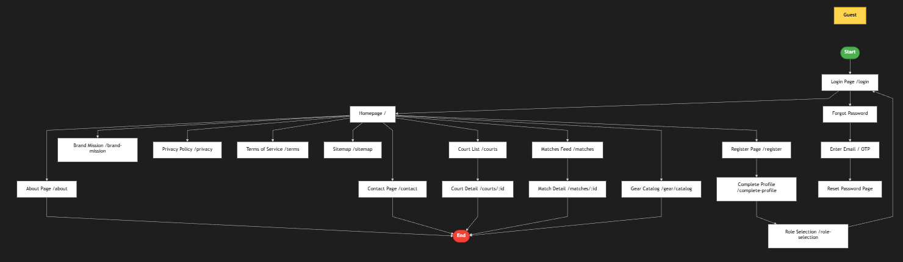
Figure 7. Screen flow Diagram – Guest
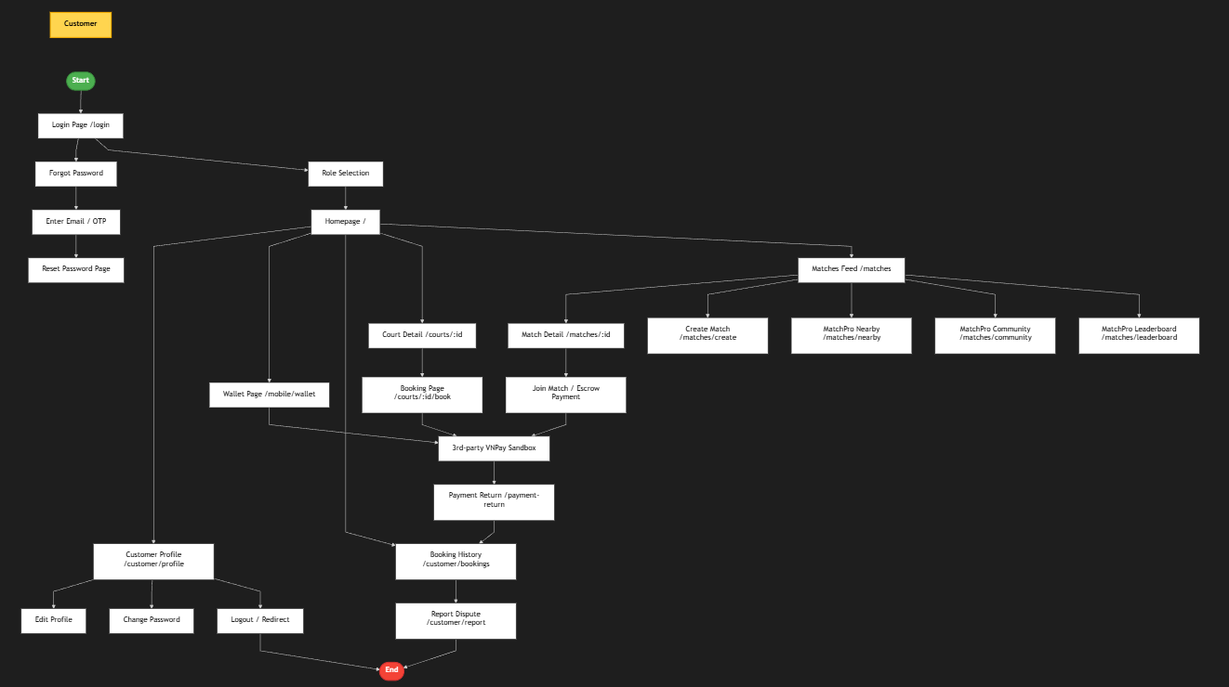
Figure 8. Screen flow Diagram – Customer
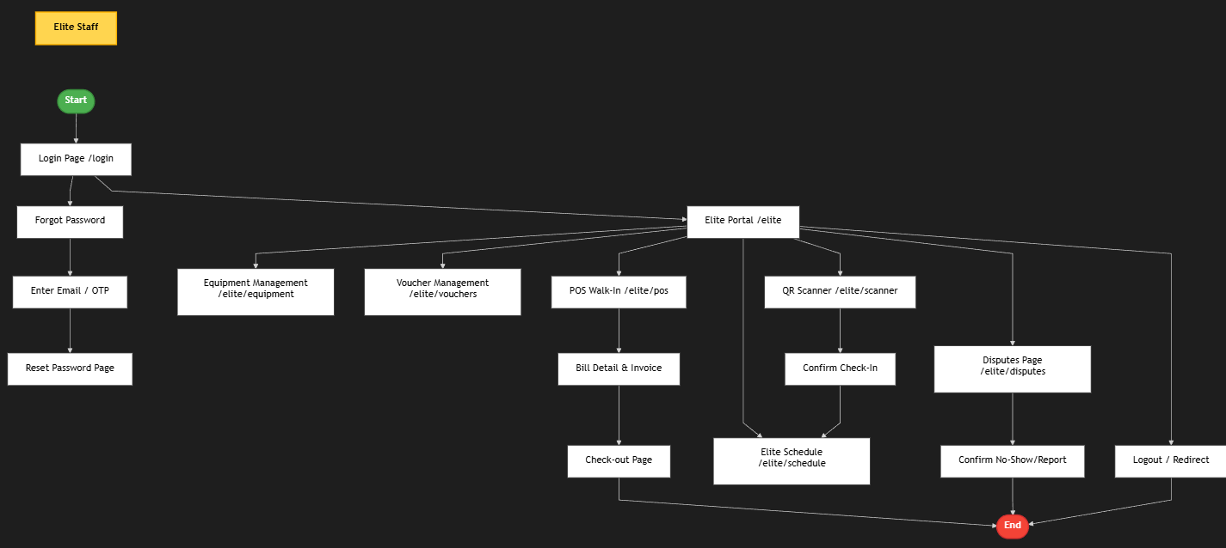
Figure 9. Screen flow Diagram – Staff
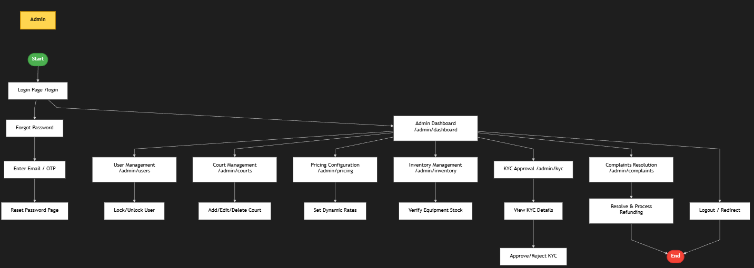
Figure 10. Screen flow Diagram – Admin

